LAB ASSINGMENT 6
Create Client_master with the following fields (ClientNO, Name, Address, City, State, bal_due)
( a ) Insert five records
Query:
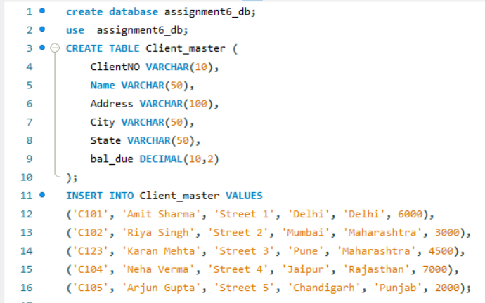
( b ) Find the names of clients whose bal_due> 5000 .
Query:
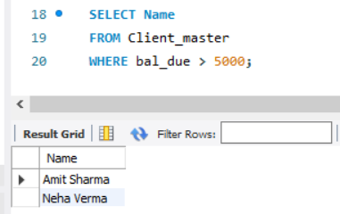

( c ) Change the bal_due of ClientNO “ C123” to Rs. 5100
Query:
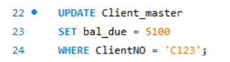
( d ) Change the name of Client_master to Client12.
Query:
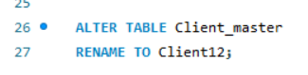
( e ) Display the bal_due heading as “BALANCE”
Query:
